FACT user guide

Importing images for FACT analysis
- To begin a FACT analysis for a new dataset, first go into FACT\Fibril width analysis\Data files, copy and paste the template folder, and rename it. In this example, we renamed it MyNewSEMimages.
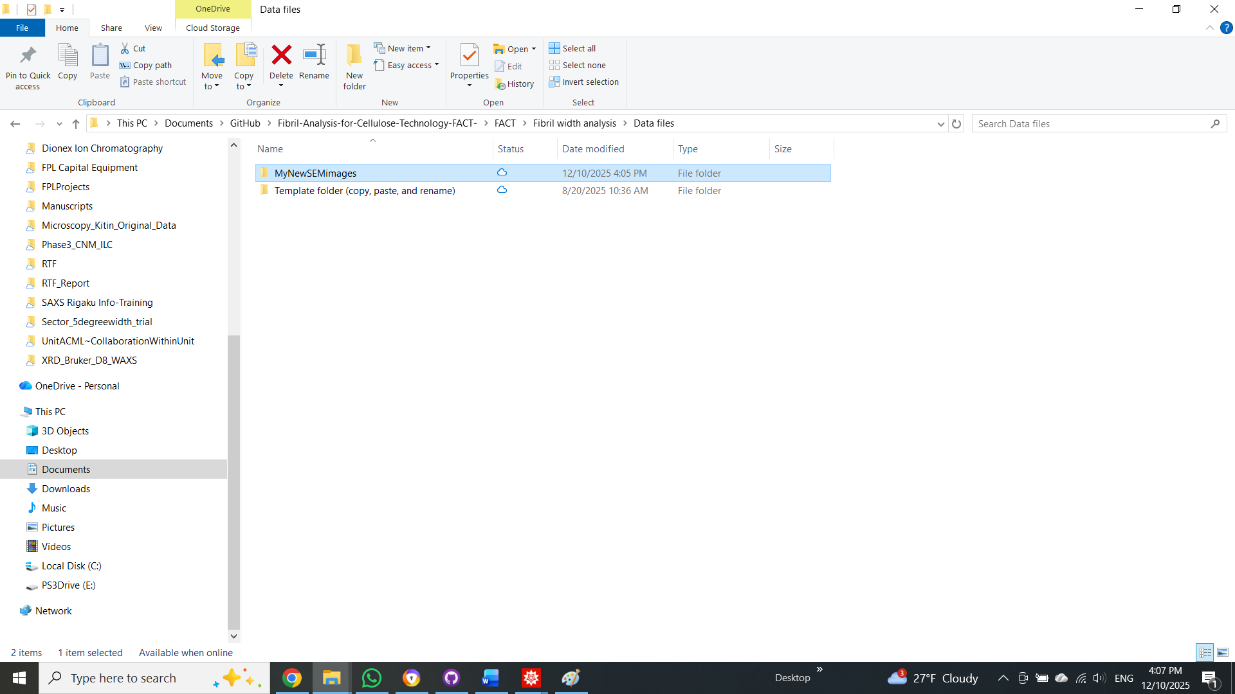
- Next, add the images intended for this dataset into FACT\Fibril width analysis\Data files\MyNewSEMimages\Original images. Open a new file explorer window and go to FACT\Fibril width analysis\Parameter files, then copy and paste the parameter file template, and rename it using the same name as the data file. Then double-click MyNewSEMimages parameter file to open this Mathematica notebook.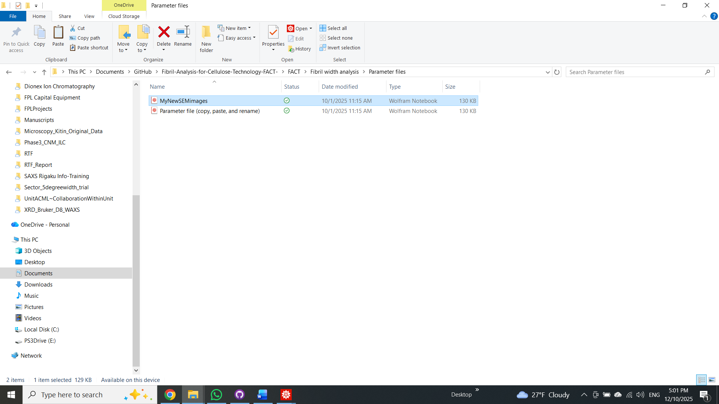
- Go to FACT\Fibril width analysis and open Width measurements_FrontEnd. Set both windows side by side. We suggest placing the FrontEnd window on the left and the parameter file on the right.
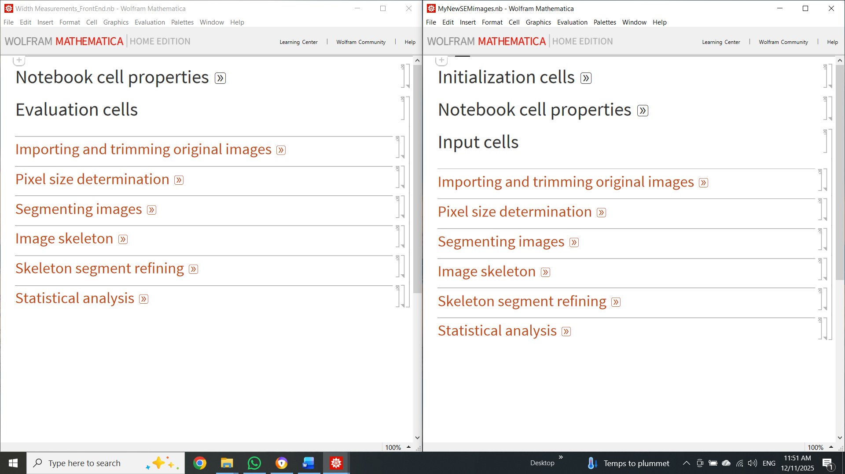

- Now we can see how the fibril width analysis section of FACT is split into subsections in the Mathematica notebook. Each subsection in the FrontEnd file corresponds to a subsection in the parameter files. As the name implies, the parameter file stores all the parameters the user selects to process the images in this dataset. The user will work sequentially through these notebooks to analyze their dataset. First, we will import the original images. For this, open the Importing and trimming original images tab in both FrontEnd and the parameter file by clicking the double arrow next to the section title. Write the name of the dataset file you wish to analyze in the variable datafn located in the parameter file. In this case, it will look like $datafn="MyNewSEMimages";$. Whenever the input needs to be a string, use quotation marks. To evaluate this line of code, first click within that line and press Shift+Enter. Then, evaluate all lines in the Import section of the FrontEnd. If the name entered in datafn matches the dataset folder name, you should see the list of imported images in the FrontEnd. Always input parameters and evaluate the parameter file section before evaluating its corresponding FrontEnd section.
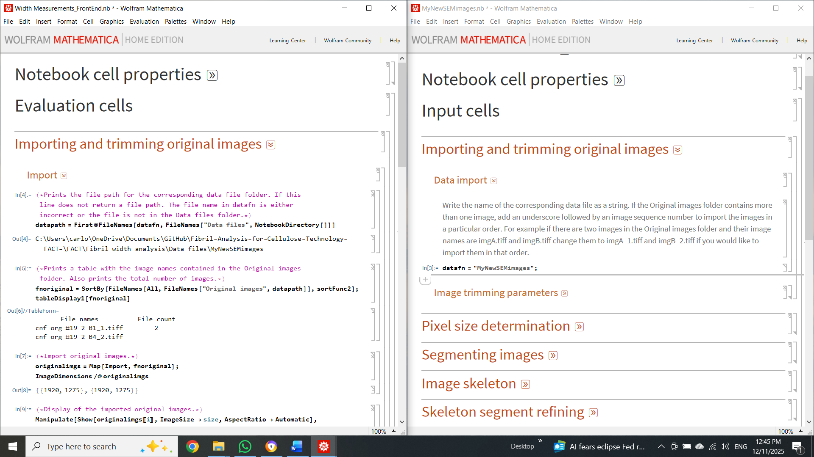

Selecting image ROI
- Next, we will trim the original images to remove the SEM information at the bottom. First, open the image trim subtab and enter then evaluate $usetrim="yes";$. Then, to add the trimming dimensions, hover over the original image display in the FrontEnd, right-click, and select Get Coordinates. The original image display supports drag-zoom, letting you zoom into the area of interest. Here, we aim to determine a region of interest (ROI), that is, a minimum and maximum x- and y-coordinate set that contains only the image while excluding the SEM information area. Then, input the selected coordinates into the variable trimdims in the parameter file as follows: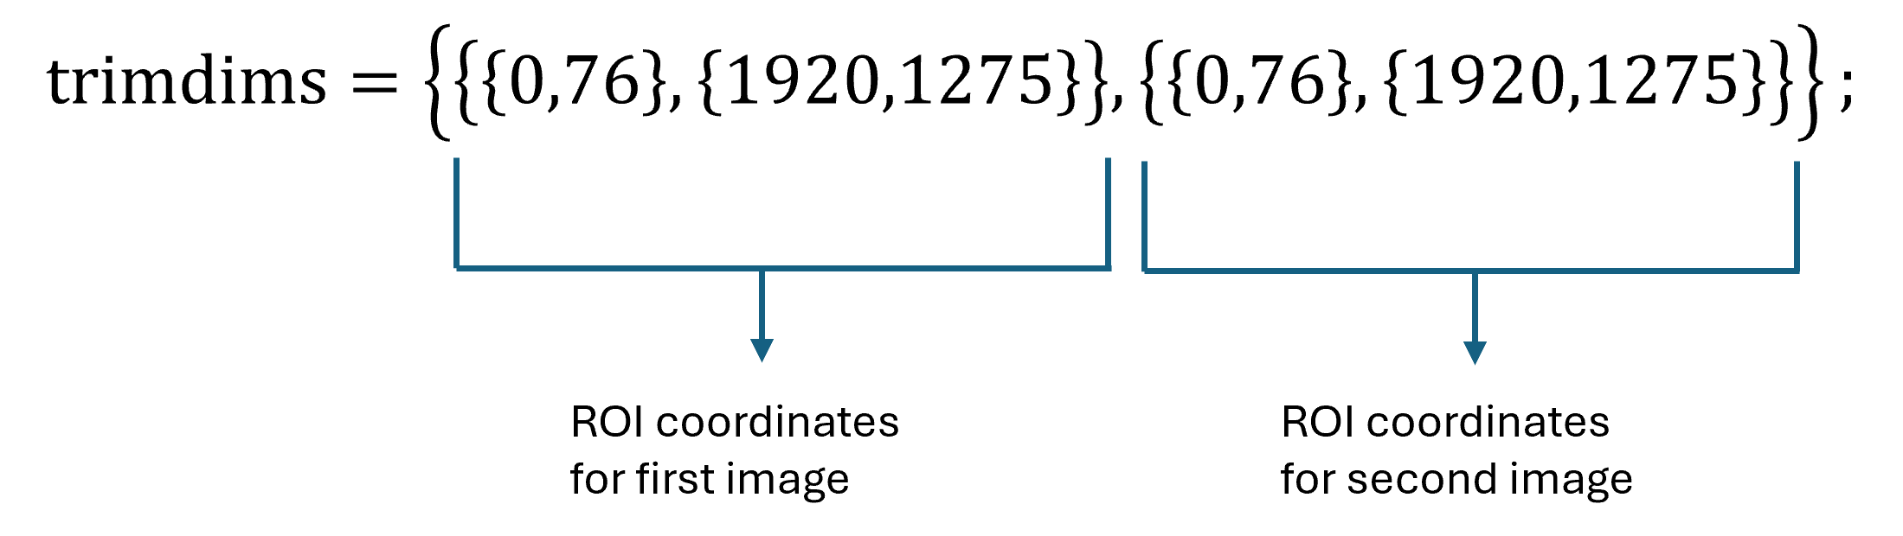
In this case, the dataset comprises two images, so only two sets of ROI coordinates are needed. Once all the ROI coordinates are input into trimdims, evaluate this line, then evaluate imgtrimres, and display the result. If satisfied with the results, export the trimmed images by evaluating the line in the export trimmed images subsection. The trimmed images will be automatically saved in FACT\Fibril width analysis\Data files\MyNewSEMimages\Result file\Trimmed images.

Calculating pixel size
- In this next section, we will use the scale bar length and magnitude to compute the image pixel size. First, go back to the original image display and drag-zoom into the scale bar region. Right-click and select Get Coordinates to find the minimum and maximum {x,y} coordinates that encapsulate only the scalebar ROI. Enter these numbers into the scalebarroi variable in the parameter file. Remember to input the ROI coordinates for each image. Then, evaluate scalebarimg in the FrontEnd. Only the scale bar of each image should be visible in this result. If this is not the case, adjust the ROI values and reevaluate.
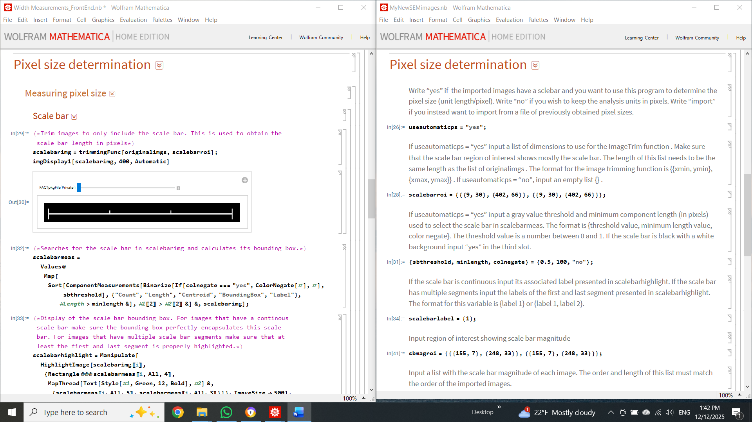
- Next, to detect the scale bar as a single object, the scale bar image will be binarized by thresholding. In this case, using the following parameters: $\left\{sbthreshold,minlength,colnegate\right\}=\left\{0.5,100,"no"\right\};$ works to identify the scalebar when evaluating scalebarhighligh. Here, we are looking for scalebarhighlight to identify one component per image and label it 1. The identified component will be encased in a red translucent bounding box. If this is not the case, the previous parameters may need to be adjusted. Evaluate the line pixelcount to determine the length of the scale bar in pixels.
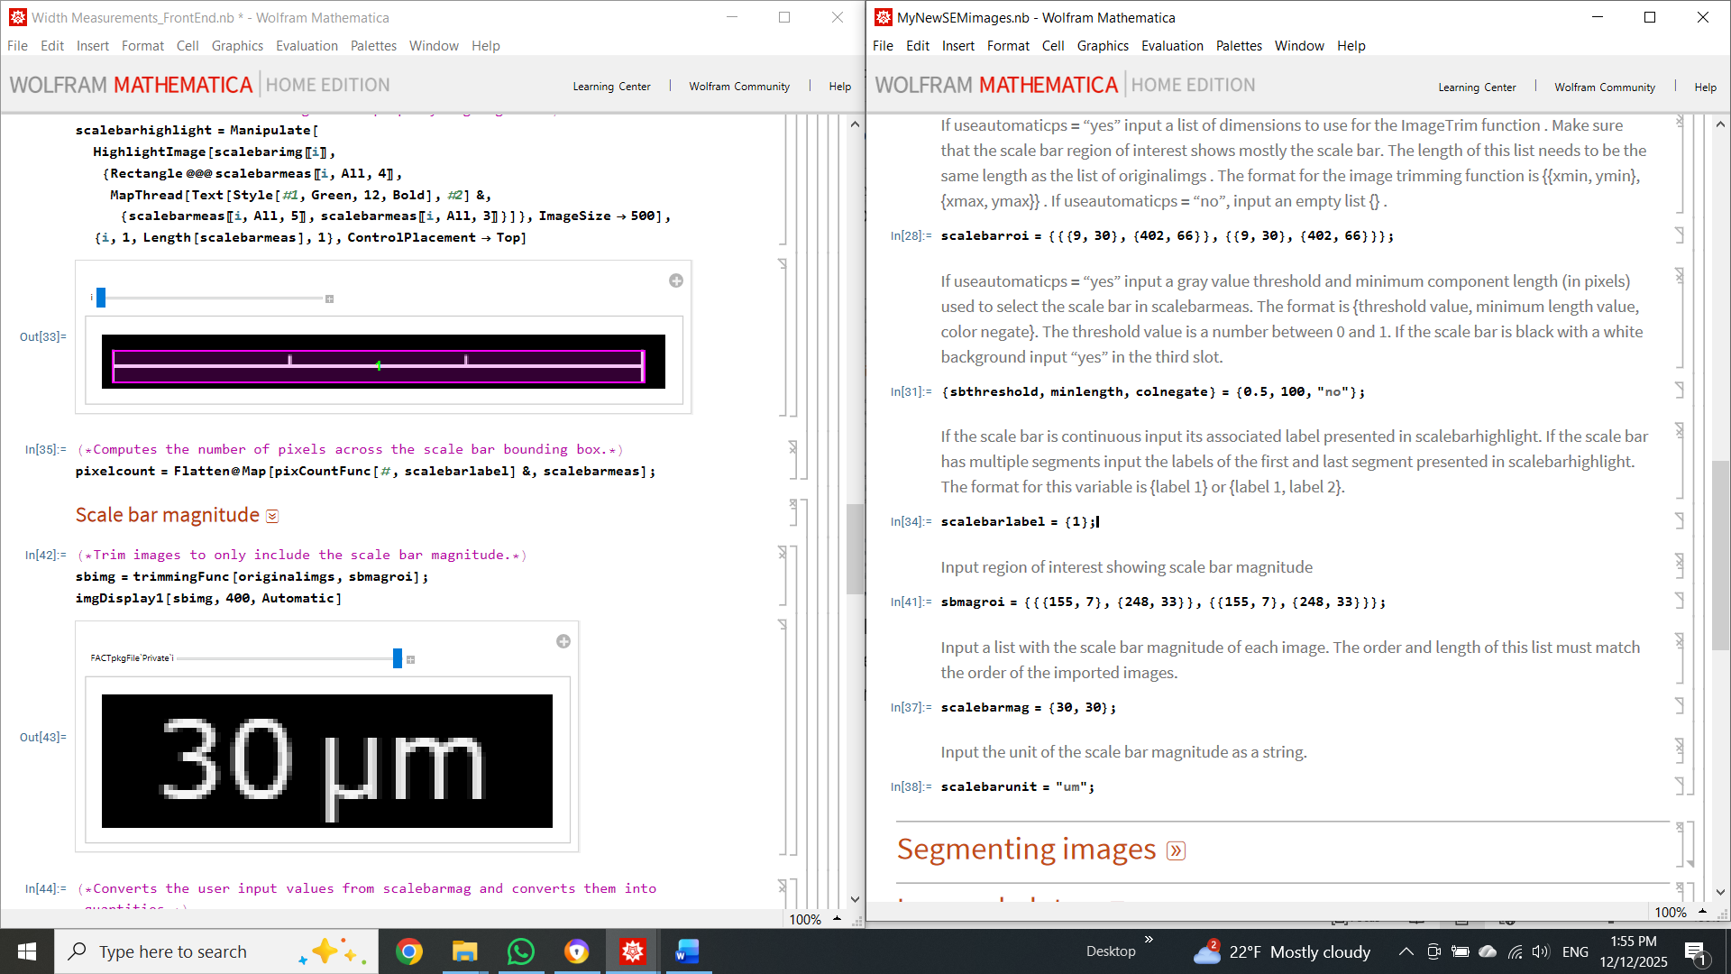
- Now we need to enter the scalebar's magnitude. Following the same procedure as before, determine the ROI coordinates that only contain the scalebar magnitude. Enter these values in sbmagroi. Then, manually enter the magnitudes in scalebarmag. Use the included visualization tool to compare and ensure that the user-input scale bar's magnitude matches the image's magnitude value. If this is the case, evaluate the last couple of lines to compute the pixel size for each image and export this information. 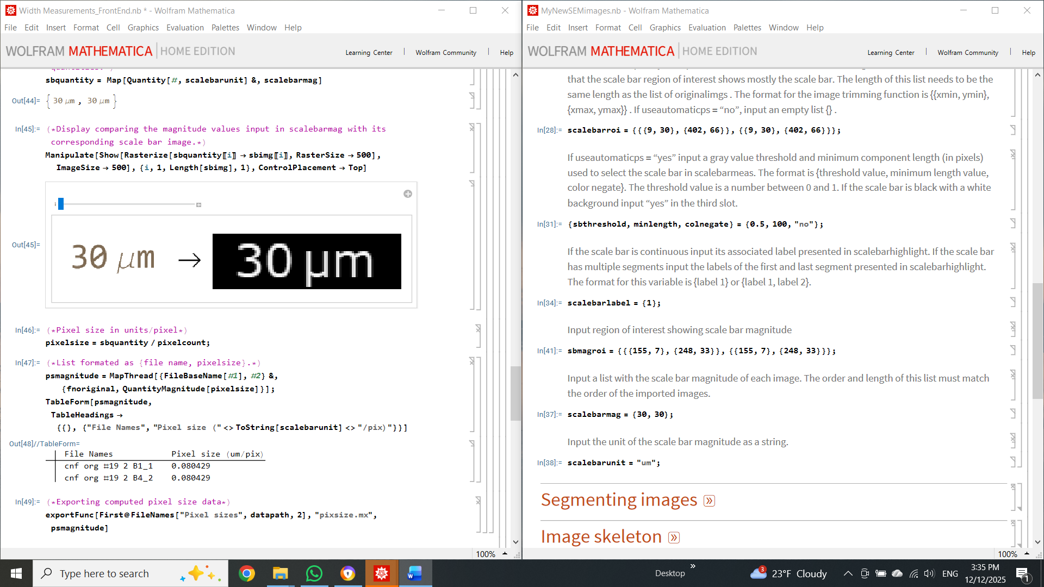

Image segmentation
- The next step in the FACT analysis is to acquire an adequate binary segmentation of the imported images. In this analysis, we aim to classify pixels belonging to cellulose nanofibrils (CNFs) as foreground and those belonging to the substrate or other unwanted particles as background. The time and effort required for this step depend on the complexity of the images. If the image has sufficient contrast between the background and foreground, a simple histogram threshold would suffice for the segmentation. Otherwise, a convolutional neural network (CNN) can be used for this task.
A CNN trained on various Negative contrast SEM images is included in FACT. The user can use this trained network to segment the previously obtained trimmed images. Additionally, the user can use FACT to train a new CNN (either by continuing training a pretrained CNN or starting from an untrained CNN) by creating new training images from their own dataset. For now, we will continue this guide by using the pretrained CNN. The latest version of this CNN is labeled CNFNegcSEM_U2Net_100R_V2.
- First, at the top of the Mathematica notebook, go to Cell – Delete all output – then save and close both the parameter file and the Width measurements_FrontEnd.
- Then, go to FACT\U^2-Net Segmentation\Parameter files. Copy and paste the template parameter file, then rename and open it. Then go back to FACT\U^2-Net Segmentation and open U^2-Net_FrontEndV1.1
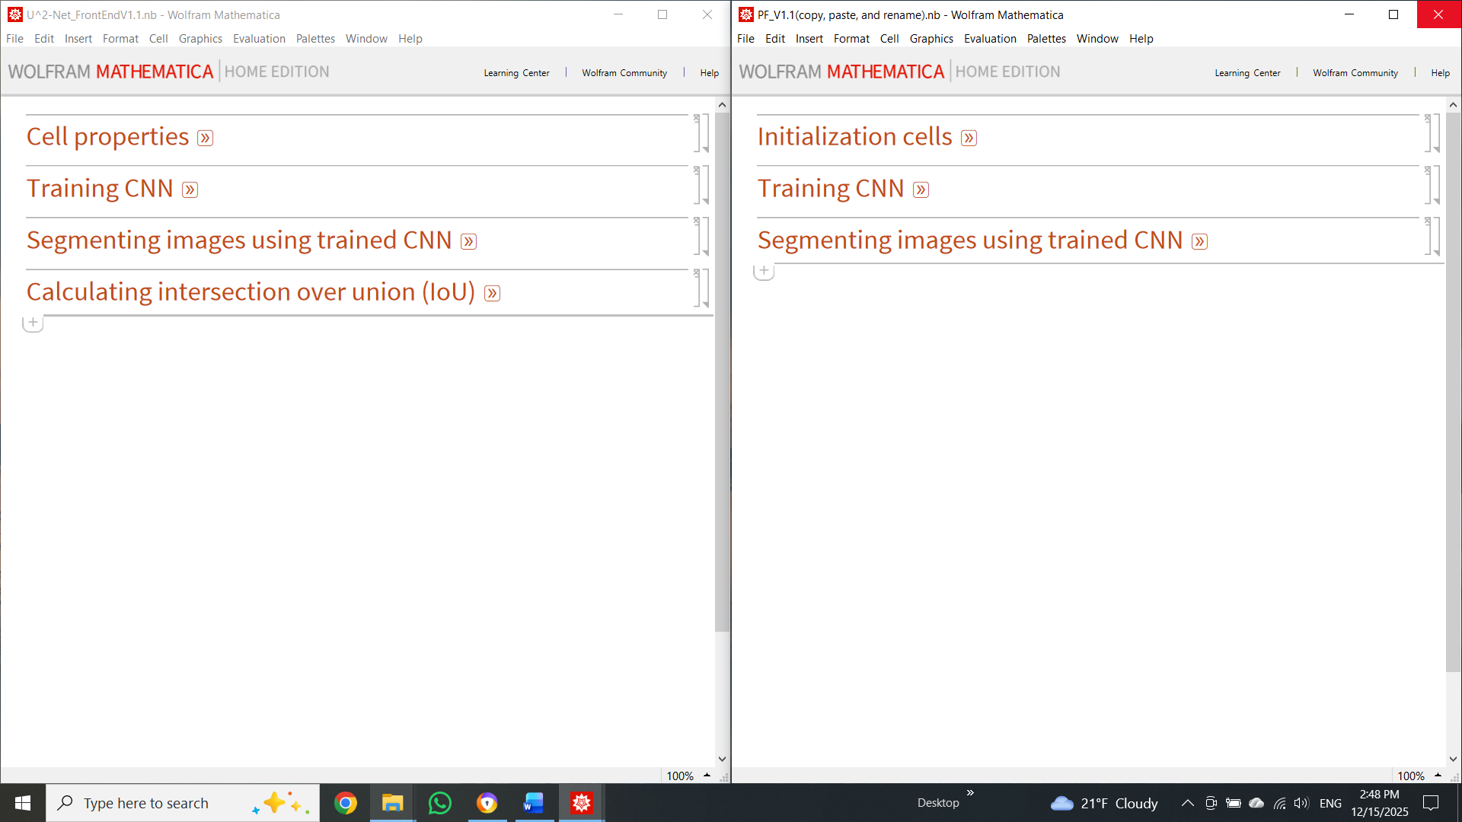
- For now, we are only interested in using a previously trained CNN for image segmentation. Therefore, we will start by opening the Segmenting images using trained CNN tab in both the parameter file and the front-end. First, add the file path to the trained CNN. The simplest way to do this is to find the trained CNN in your file explorer window and copy it (Ctrl+C). The trained CNN should be stored in FACT\U^2-Net Segmentation\Trained U^2-Net. Then, place your cursor after trainedpath= in the parameter file and paste (Ctrl+V). Mathematica will add the complete path directory to that line. Then add the path to the folder containing the trimmed SEM images intended for segmentation. Here, the user can add multiple folder paths containing trimmed SEM images. In this example, we only added one folder path to imagepaths.

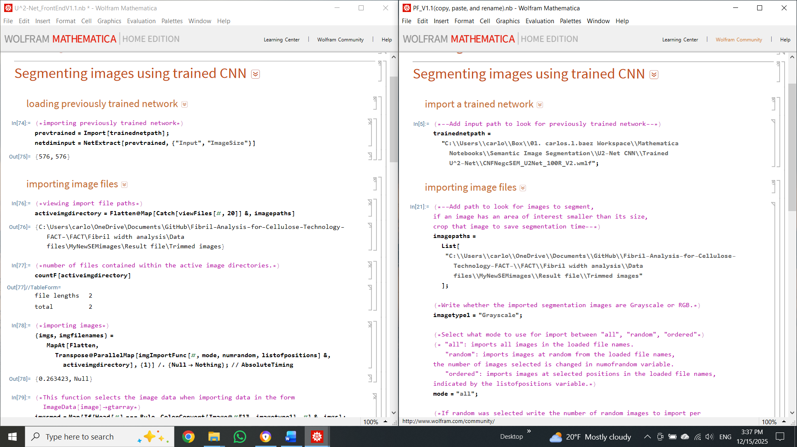
- Evaluate the parameters in this section, then load the CNN and import the image files by evaluating the corresponding section in the front end. To begin image segmentation, segment a test image to ensure everything is working correctly. If so, segment all imported images by evaluating all lines in the next section. Assess the segmentation quality using the included visualization tools. If the segmentation quality is satisfactory, export all images in the next section. To export, copy and paste the file path into ouputdirectory in the parameter file. Export the segmentation results to FACT\Fibril width analysis\Data files\MyNewSEMimages\Segmented images.
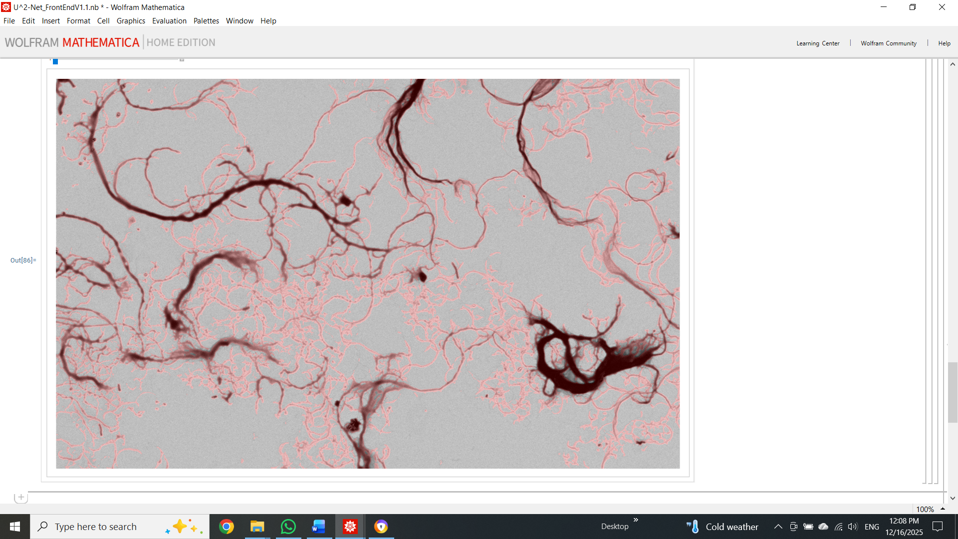
- If the segmentation is not satisfactory, new training images from the current dataset will need to be generated, and the CNN retrained. For FACT analysis, we suggest using the Weka plugin in ImageJ to generate new training images. Jump to section Training CNN to learn how to create training images using Weka.

Image skeletonization
- After exporting the image segmentation results, close all Mathematica notebooks. Then, go back to the Fibril width analysis folder and reopen the Width Measurements_FrontEnd and the parameter file MyNewSEMimages. Evaluate the parameter file, then from the FrontEnd evaluate the following:
Importing and trimming original images – all lines from the Import and Image trim subsections
Pixel size determination – all lines from the pixel size data select subsection
Segmenting images – all lines from Importing CNN segmented images (make sure to enter $binselect="import";$in the parameter file)
Next, to test the method, we can skeletonize a selected image and view the result. Evaluate the functions located in Image skeleton – Skeleton of single image and Visualizations 1.
- To continue, evaluate all lines from the section named skeleton of all images. Here, the user needs to select the Gaussian filter kernel size (kernsize1) to smooth the binary images. The kernel size can be set to 0 to forgo this filter. In this section, the user can select to filter out individual particles using a minimum count and/or minimum component elongation filter. Set these parameters to 0 to forgo these filters. $\left\{mincount1,minelongation1\right\}=\left\{0,0\right\};$Finish by exporting the skeletonization results.

Skeleton segment refining
- The next step is to refine the skeleton network. Here, the intent is to trim and/or remove unwanted skeleton segments and include in the statistical analysis only those that align with fibril centerlines. First, evaluate all lines from the Skeleton partitioning and measurements section to partition the skeleton network into individual skeleton segments, and extract the coordinates of these segments.
To begin skeleton segment refinement, enter a drop fraction in the parameter file (a number between 0 and 1). The variable dropfrac represents the fraction of points on each skeleton segment that will be removed from the ends. We will call this skeleton segment trimming (SST). Skeleton ends near junction points tend not to follow the fiber centerline. Trimming these ends helps reduce that contribution. Practical values range from 0 to 0.3.
- Next, enter an angle (practical values between 10 and 60 deg) in the variable anglethreshold to remove from the analysis all skeleton segments with a distance transform rate of change exceeding the input angle. We will call this skeleton segment filtering (SSF). Skeleton segments resulting from a jagged-edge artifact tend to have high SSF angles. The lower the angle entered, the more skeleton segments will be removed. The user needs to exercise judgment and, by trial and error, determine which value removes mostly unwanted skeleton segments while keeping those that follow fibril centerlines. Users are encouraged to use the included visualization tools to help determine whether the refining parameters are acceptable. Once all lines are evaluated in the skeleton segment and filtering section, go to section Visualizations 2 – Filtered skeleton overlay to obtain the skeleton refining results as an overlay image with and without a scale bar. This section allows exporting these overlay images.

Fibril width statistical analysis
- To finish the FACT analysis, evaluate all lines in the Statistical analysis section. In the parameter file, the user can choose from several options for grouping and visualizing fiber-width statistical data. The resulting fiber width data can be exported as xlsx, csv, JSON, or txt for plotting in other software or for subsequent analysis.
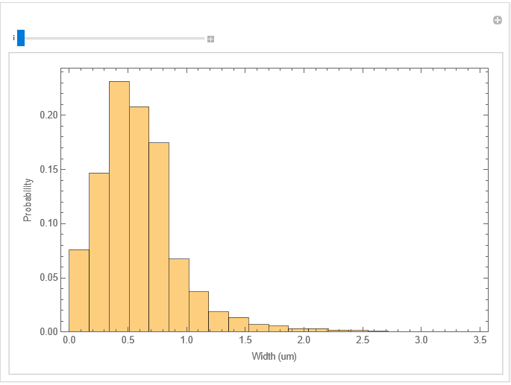

Training CNN
- CNN training may be necessary if the segmentation results are not satisfactory. To train the U^2-Net CNN, the user must first create new training images. Here, we will use Weka, a FIJI plugin that allows the user to assign classes to different regions of the image using the included FIJI drawing tools. Weka uses the user-provided pixel classifications as input and trains a machine learning model to generate a class-probability map of the current image. The default machine learning model in Weka is a random forest.
- To begin, go to FACT\U^2-Net Segmentation\Training sets, then copy, paste, and rename the template folder. Here, we named the new folder "New data set." Open this new folder and add the trimmed SEM images you wish to use for training to the target images folder.
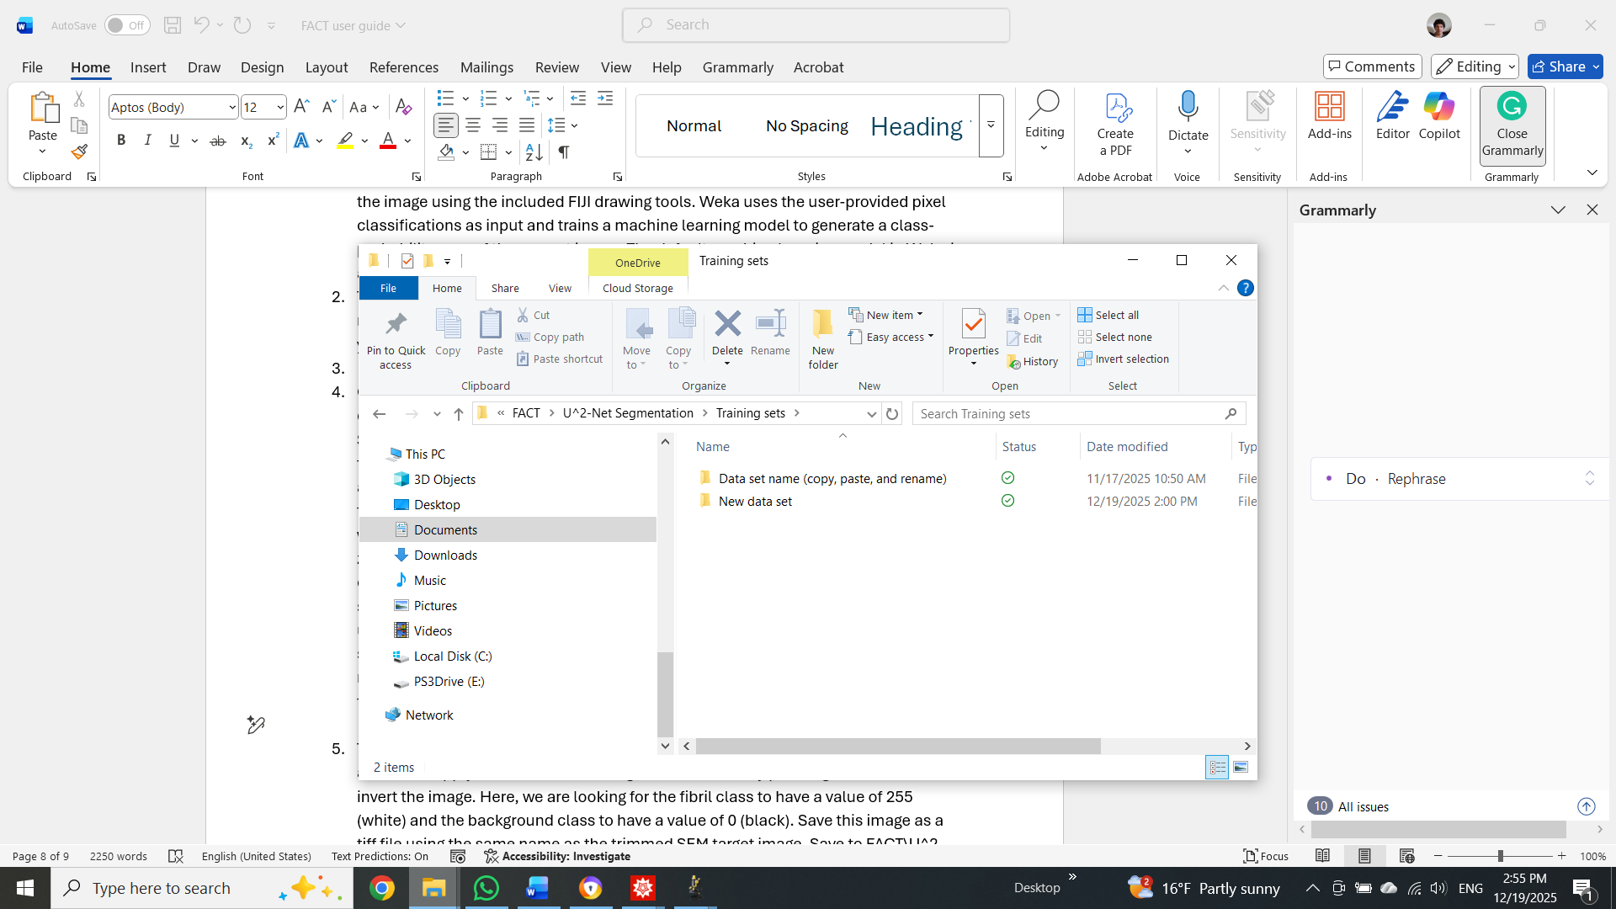

- Open FIJI, then select the first target image you wish to work with by dragging and dropping it into the FIJI interface. Next, in the FIJI menu, go to Plugins -> Segmentation -> Trainable Weka segmentation. Use the drawing tools to paint the fibril regions and add them to class1. Similarly, paint the background regions and add them to class2. We suggest using the freehand drawing tool: right-click the Line tool and select Freehand line. Then, double-click the Freehand line tool and set the width to 1 pixel for maximum control over pixel selection. Use the zoom-in and zoom-out (+/- keys) to help select pixels. Once there are about 5 to 10 entries per class, press the 'train classifier' button. Once the model finishes training, it will show you an update on its performance by overlaying the segmentation result. The user needs to determine whether more training data is necessary. If so, keep selecting more class examples for each class until, after training the model, the segmentation is satisfactory. The number of examples needed to achieve good results typically ranges from 10 to 30 per class, depending on the image's complexity.

- To export the segmentation result, click Create result, then Ctrl+Shift+T, click auto, then click apply, to threshold the image values. Finish by pressing Ctrl+Shift+I to invert the image. Here, we are looking for the fibril class to have a value of 255 (white) and the background class to have a value of 0 (black). Save this image as a tiff file using the same name as its corresponding trimmed SEM target image. Save to FACT\U^2-Net Segmentation\Training sets\New data set\ground truth images.

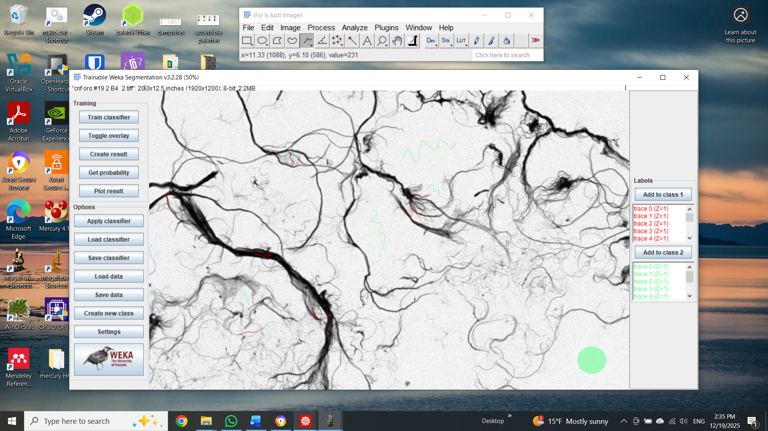
- Here is an example of the resulting binary image. This image can now be included in the U^2-Net training set. Repeat the process for the remaining images in the target images folder and close FIJI.

- Next, go to FACT\U^2-Net Segmentation and open U^2-Net_FrontEnd and the corresponding parameter file. Open the Training CNN - import paths, add the paths into trainingdatasets as shown.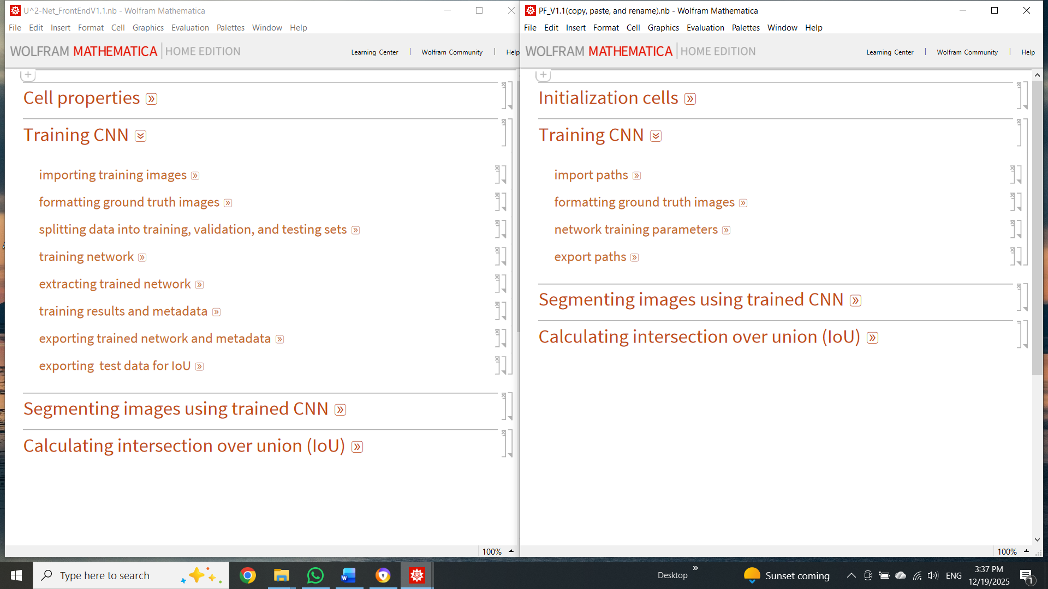 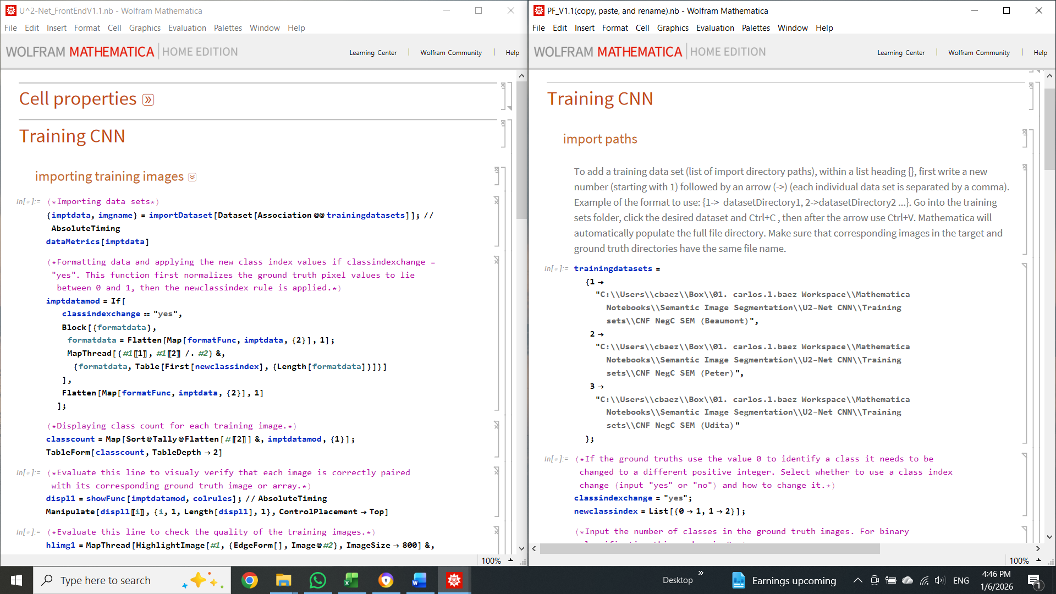
- In binary classification, the imported ground-truth images have pixel values of 0 or 255. To train the CNN, each class must be represented by a unique positive integer (zero is not allowed). In this case set classindexchange = “yes”, newclassindex = List[{0->1, 1->2}]; and numofclasses = 2;. Next, evaluate all lines within importing training images subsection. Here, all training images from the training datasets are imported and displayed.
- Next, in the formatting ground truth images subsection, evaluate inputdims. Select a network image input dimension from the list and enter the number in the variable netinputdim located in the parameter file. This value is user-selected and depends on the computer's available VRAM. For example, if available VRAM is 4 GB, select a number near 100, and if VRAM is 24 GB, select a number between 500 and 700. More VRAM allows the CNN to be trained on larger subimages. Select the fractions used to split the training data between training, validation, and test sets. Evaluate the rest of the lines in the formatting ground-truth images from the parameter file, then in the front end.
- Evaluate all lines in the network training parameters. Here, the user can either import a previously trained network for continued training or start over with an untrained network. Select the total number of training rounds and the training batch size. Then, add corresponding export paths for the trained network, training metadata, and test data.
- Once all relevant variables are entered and evaluated in the parameter file, finish by evaluating the following frontend subsections: splitting data into training, validation, and testing sets, training network, extracting trained network, training results and metadata, exporting trained network and metadata, and exporting test data for IoU. Training time is proportional to the amount of training data used and the number of training rounds, and inversely proportional to the training batch size.

